ADRIAN TURION |  | Avenue de Sainte-Clotilde 9  1205 Geneva, Switzerland | 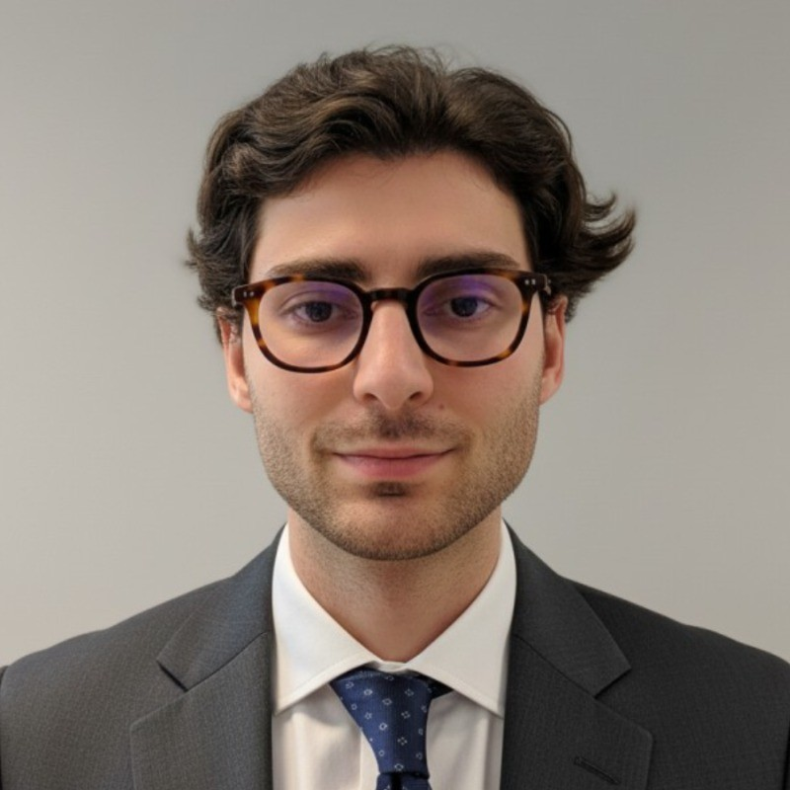
turionadrian@gmail.com | Swiss | 10.11.2000 |  | +41 77 262 37 96
INTRODUCTION
Deal execution-focused MSc Finance candidate with end-to-end transaction experience across valuation, due diligence, and closing in a lean team environment. Strong financial modeling expertise (LBO, DCF, comps) and cross-border deal coordination across Europe. Proven project management skills handling multiple concurrent mandates with external advisors.
WORK EXPERIENCE
Auraïa Capital Advisory – Small & Mid Cap Cross-border M&A Boutique  Mergers & Acquisitions Analyst (Converted internship into full-time position) |  | Geneva, Switzerland  Aug 2024 – Current
- End-to-end execution exposure in a lean 3-person deal team: sourcing, valuation, due diligence, negotiations, and closing on 10+ live mandates across healthcare, tech, and life sciences with deal values from EUR 5M to EUR 50M
- Built detailed financial models (LBO, DCF, trading comps, precedent transactions) and prepared investment memoranda and client presentations for Board meetings and investor pitches across multiple concurrent mandates
- Coordinated with legal, tax, and accounting advisors to structure transactions and negotiate deal terms, managing data rooms and ensuring alignment across all stakeholders throughout the transaction lifecycle

RC Group – Currently under LBO with Crédit Mutuel Equity  Mergers & Acquisitions Intern |  | Paris, France  Feb 2024 – Aug 2024
- Prepared investment memos including market analysis, competitive positioning, and financial projections for 3 potential acquisitions, working directly with the CEO of Healthcare and Retail divisions on evaluating targets in France and Belgium with revenues of EUR 10M-30M

Europ Assistance – Subsidiary of Generali Insurance  Financial Analyst Intern |  | Geneva, Switzerland  Apr 2023 – Aug 2023
- Supported CFO and Head of Controlling on FP&A and strategic projects for Swiss subsidiary (CHF 50M+ revenues), preparing Board presentations on financial performance and building automated Excel dashboards to track KPIs and perform variance analysis

LEADERSHIP
- McKinsey Case Finalist: Presented strategic project to Keyrock's management and McKinsey consultants, developing data-driven model showcasing CHF 200K annual revenue potential
- Screeny.ai Founder: Built AI-driven buyer identification tool for investment banks, reducing search time from 10h+ to 20min; adopted by 3 advisory firms
- Portfolio Manager: Manages diversified investment portfolio using options strategies, generating +8% annualized returns through disciplined risk management
EDUCATION
HEC Lausanne  Master of Science in Finance |  | Lausanne, Switzerland  2021 – 2024
- Cumulative GPA: 5.2/6.0 (Top 15% of the class cohort)
- Exchange programs at Waseda University (Tokyo, Japan) and Maastricht University (Maastricht, Netherlands)
- Relevant Coursework: Corporate Governance and M&A, Valuation, Corporate Finance, Derivatives
- Thesis Topic: Synergies Analysis of the Merger between American Airlines & US Airways

Bachelor of Science in Management |  | 2018 – 2021
- Cumulative GPA: 4.7/6.0

Scientific Baccalaureate with Highest Honors (16.6/20) |  | Aix-en-Provence, France
ADDITIONAL INFORMATION
Languages:  Computer:  Interests:  References: | French (Native, C2), Spanish (Native, C2), English (Fluent, C1), German (Business proficient, B2-C1)  Financial Modeling, Valuation, M&A Execution, Due Diligence, Project Management  Geopolitics, Badminton (Provence regional finalist), Gym, Real use cases of Artificial Intelligence  Guillaume Arnaldez – Ex-Director at Auraïa Capital Advisory, guillaume.arnaldez@auraia.ch  Sacha Caravatti – CFO at Europ Assistance Switzerland, scaravatti@europ-assistance.ch

